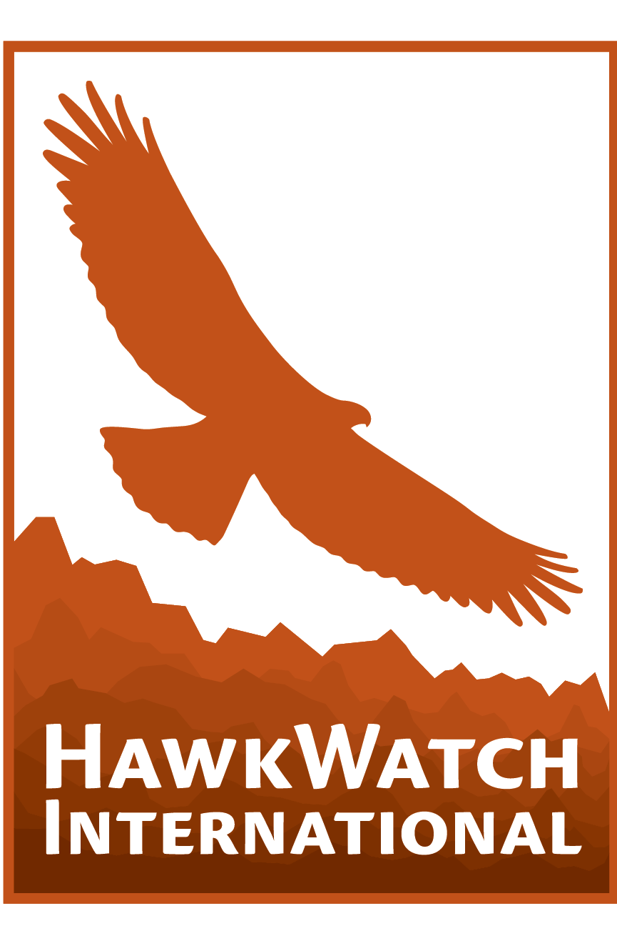
Global Raptor Research and Conservation Grant Application Form

Overview
Details of grant application deadlines, funding objectives, and previous projects can be found on the website: https://hawkwatch.org/investing-in-others/grrcg/

To apply, complete this application in English and email it as a single document, including appendices, to conservation.grant@hawkwatch.org

All applications must remain strictly within the word limits and the following guidelines:
- Use 12-point font throughout.
- Supporting materials can include up to five additional pages of Appendices (listed below) and should be inserted within this document.

Background Information

Applicant Name
Email Address and Phone Number
Residential/Postal Address
Nationality
Applicant must be a citizen of the country where the research is taking place.
Location of Project
Country and geographical region. Include map as appendix.
Supporting Institute and Your Affiliation
The university/NGO/institute where the applicant is based, or who will partner to accept funds. If selected for funding, a letter of support from the organization will be required.
Academic Status
Indicate if this research forms part of a university degree.

Study Species
Species IUCN RedList Status
Species Global Population Size and Reference of Data Source
If available, use the latest IUCN RedList assessment.
RCPI Score

Project Details

Project Title

Abstract
Summary of project (200 word limit)

Introduction
Detail information on the current knowledge of the species, threats, and study site. Up to (200 word limit)

Objectives
Describe your overall study objectives, outlining the research or conservation action to be addressed, and give specific aims/objectives which will be undertaken, including why and how they will be achieved. (250 word limit)

Methods
Clearly describe your research methods, specifically fieldwork methods, data collection, and analysis. Quantify sample sizes, survey duration and timing, and why. (500 word limit)

Conservation Importance
Detail how the project will contribute to the conservation of the species locally, and throughout its distribution. (150 word limit)

Outcomes or Deliverables
List your conservation outcomes, measures of success and/or deliverables (e.g. project report, scientific publication, number of people engaged, number of mortalities reduced). (150 word limit)

Project team
Give names and brief summaries of roles and relevant experience and/or qualifications of the key persons involved, including the applicant. (200 word limit)

Biography/letter of motivation
Explain how this project relates to your previous work, to your career goals, and how it may contribute to building capacity for raptor conservation in your country. (500 word limit)

Permits
List any ethical, regional permits or permissions required to carry out this project and expected timeline to acquire them

Timeline
Detail when each component of the project will start and be completed. Projects must be completed within 18 months of grant receipt.

Literature cited

Referee
Name, address, and email of someone who can comment knowledgeably on your application, such as a species expert or previous supervisor (not someone currently involved in this project).

Budget
Budget must be shown in US $
Grant Amount Requested
Total Project Budget
Includes all expenses, even those not covered by this grant request

Please be thorough and clearly indicate how the budget will be spent within the project. Add rows as necessary and remove the example budget in the table below.

Use the following classes for “Purpose” and “Category”:
- Purpose: Data Collection, Analysis, Publication, Outreach/Meetings, Conservation Action, Institutional Overhead (not exceeding 10%), Other (please specify).
- Category: Permits, Equipment, Transport, Meals, Stipends, Printing, Other (please specify).
- Co-funding: If relevant, please give details of any co-funding secured or required.

Purpose | Category | Item Description | Quantity | Cost | Total | Co-funding* | GRRCG
Data Collection | Equipment | Audiomoth acoustic recorders (ARU) | 10 | 100 | 1000 | 0 | 1000
Data Collection | Equipment | Temperature/humidity data loggers | 10 | 50 | 500 | 200 | 300
Data Collection | Equipment | SD cards 128GB | 10 | 12 | 120 | 60 | 60
Data Collection | Equipment | Rechargeable AA batteries + Charger | 10 | 20 | 200 | 100 | 100
Data Collection | Equipment | ARU spare parts (wind protectors, sealant, screws) | 1 | 100 | 100 | 50 | 50
Data Collection | Transport | Fuel | 1 | 1000 | 1000 | 700 | 300
Data Collection | Transport | Vehicle rental per day | 40 | 30 | 1200 | 0 | 1200
Data Collection | Equipment | Headlamps | 2 | 20 | 40 | 0 | 40
Outreach/meeting | Printing | Outreach materials for students | 5 | 100 | 500 | 500 | 0
Analysis | Equipment | Cloud storage (2TB) | 1 | 100 | 100 | 0 | 100
Institutional overhead | Overhead | Overhead 10% | 1 | 350 | 350 | 0 | 350
 |  |  |  | Total | 5110 | 1610 | 3500

*Co-funding Details
Provide details of where any co-funding has been sourced from

Appendices
Maximum four additional sides, including CV. Please insert these documents within this application file.

- Appendix 1. Map showing the location of the project.
- Appendix 2. CV/Resume. Limited to a maximum of two pages, single-spaced. Should include current position and affiliation(s), qualifications, and experience.
- Appendix 3. Copy of national ID or passport.
- Appendix 4. (Optional) Photo of study species/study location/methods or any figure relevant to this application.

